**Load balancer:**

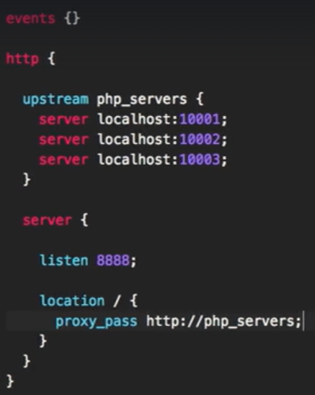

* We configure the load balancer servers as upstream as above.

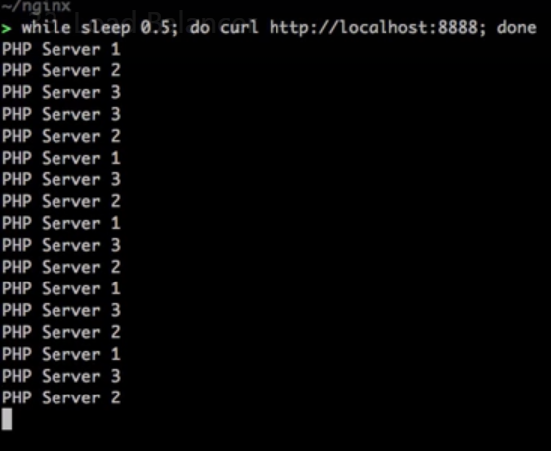

* Now, we can see that nginx is serving the requests to all the servers as above.
* It follows the round robbin.
* If we kill server1, it will keep sending the load to server2 and 3. And if we start server1 again. It will send the load to server1 again.

**Sticky sessions:**

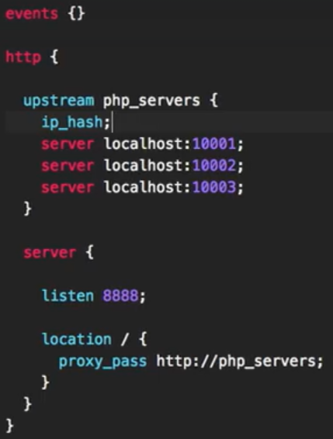

* We need to edit the config file as above.

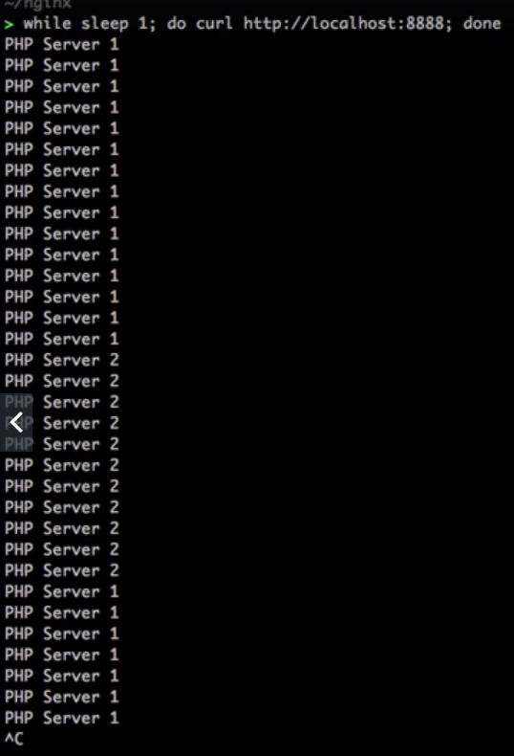

* Now, it will stick to one server. Server1 as above, if that goes down. It will use server2 and if we bring server1 back again. Then the requests will go to server1 again.